Explanation & Refrences

watches_main.html web-page look:

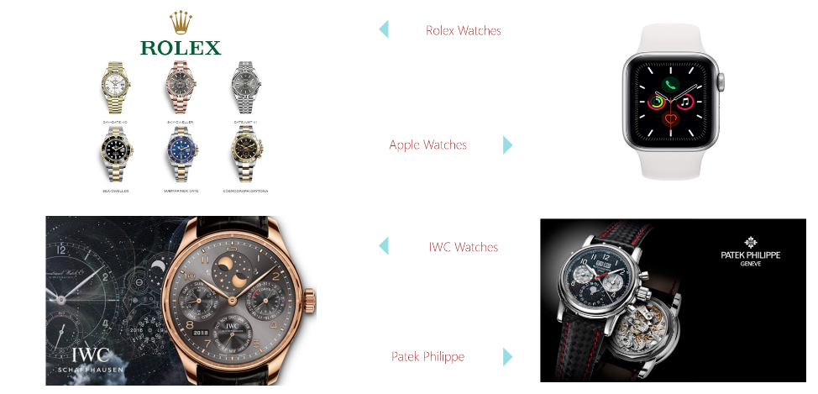

Here we first create a table and then add images and text accordingly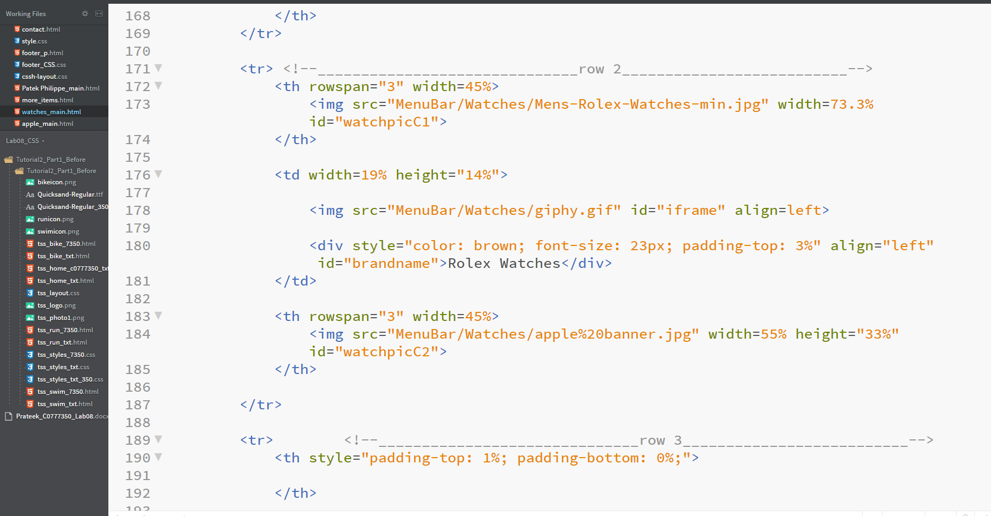

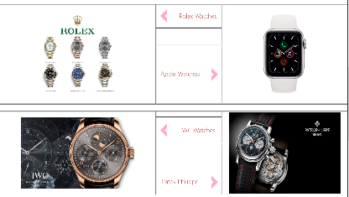 (Table look when border is 2px)

Now creating an effect that images will rotate by 4 degree . for this we use 2 ids

id="watchpicC1" & id="watchpicC2" for rotating by 4 degree and -4 deg , and then using box shadow :

(CSS Given Below)

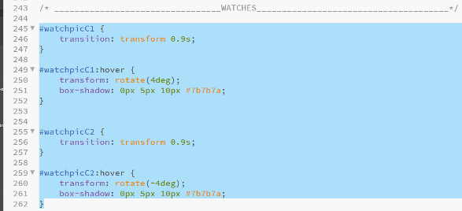

** transition : transform 0.9s;

------ determines time it will take to transform the image as per hover effect

Required Outcome ::

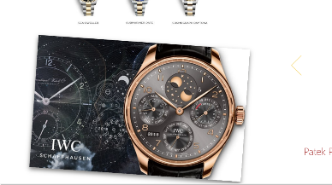

Without Favicon



Adding Favicon

CODE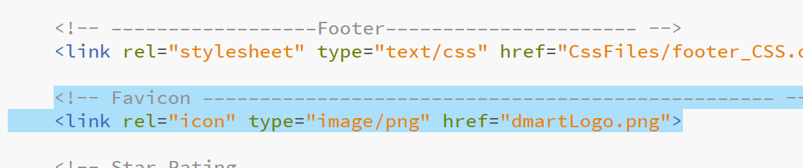

Result



Creating a Transparent Drop Down Menu

HTML code

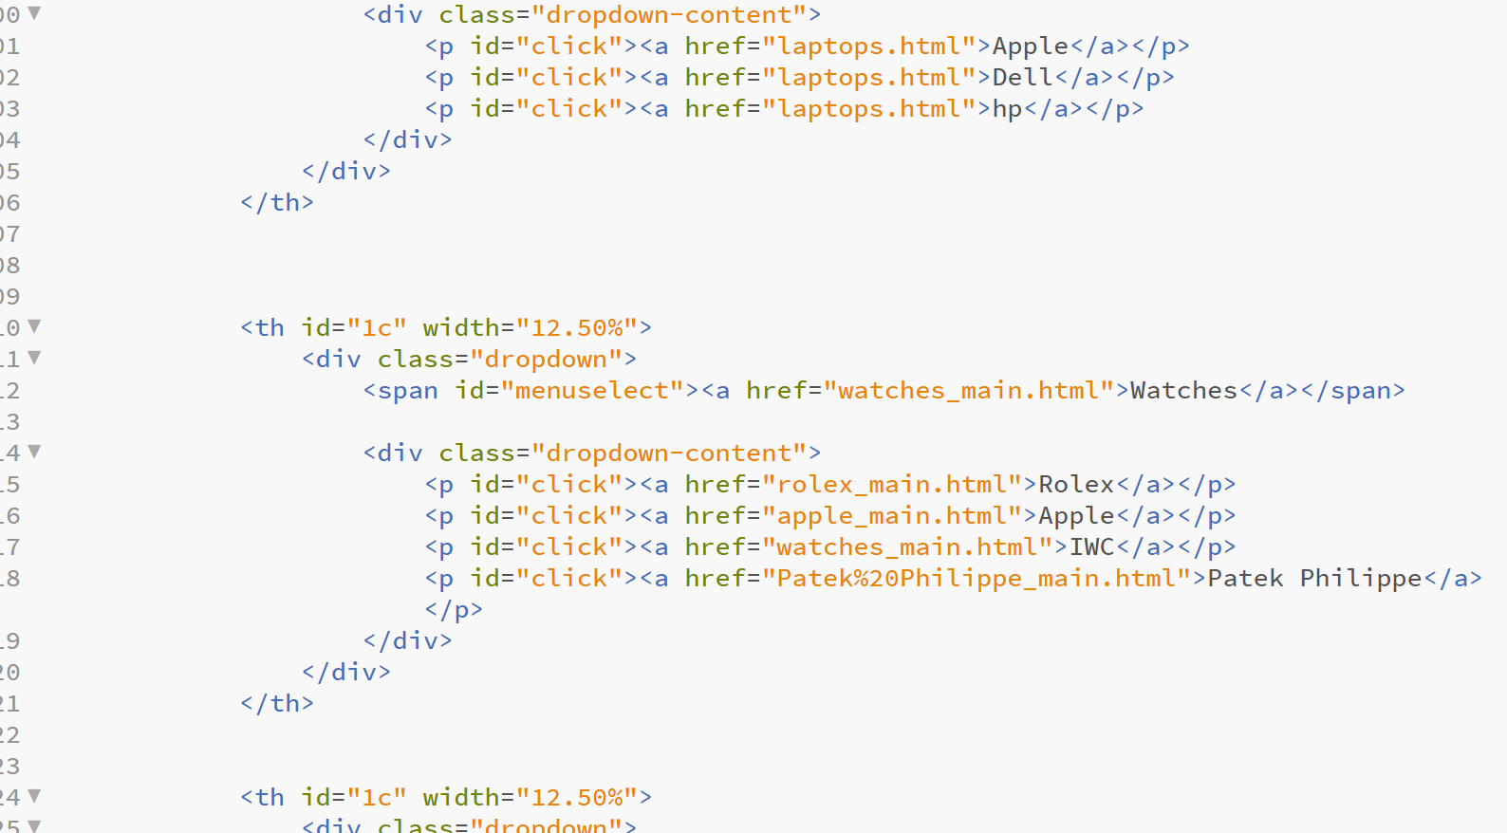

WITHOUT CSS

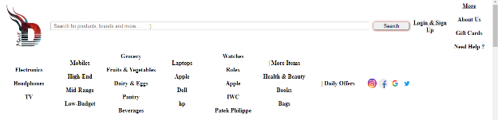

CSS styling

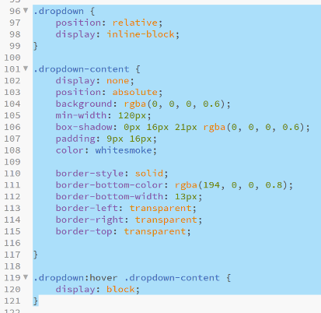

Result ::



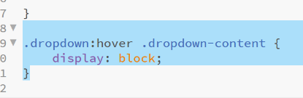🡨 DropDown When Hover

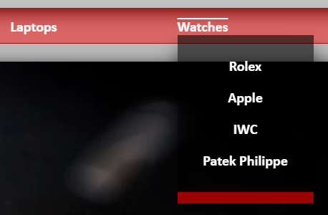

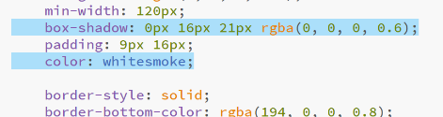🡪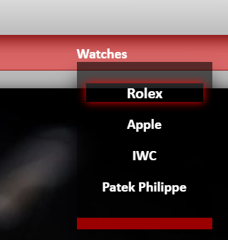

Creating a table :: HTML Code :- 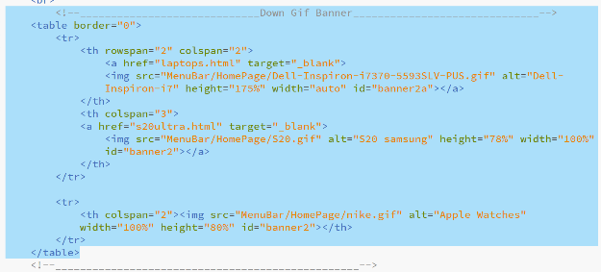

Without CSS

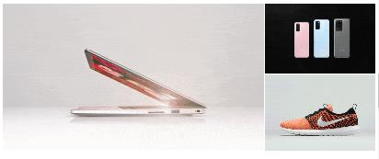

With CSS

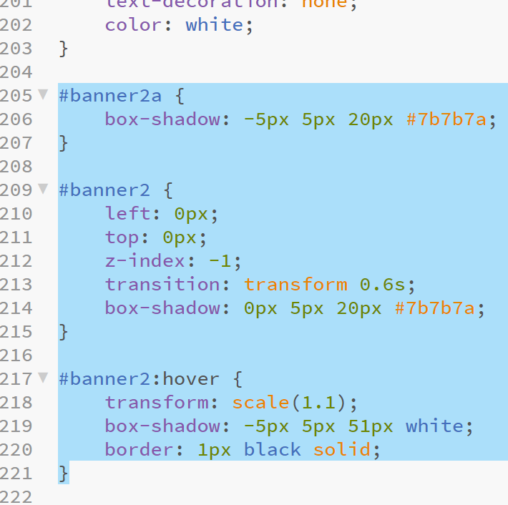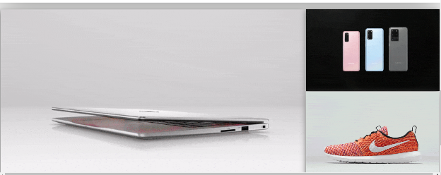

Hover Effect ::

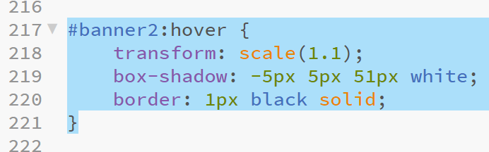

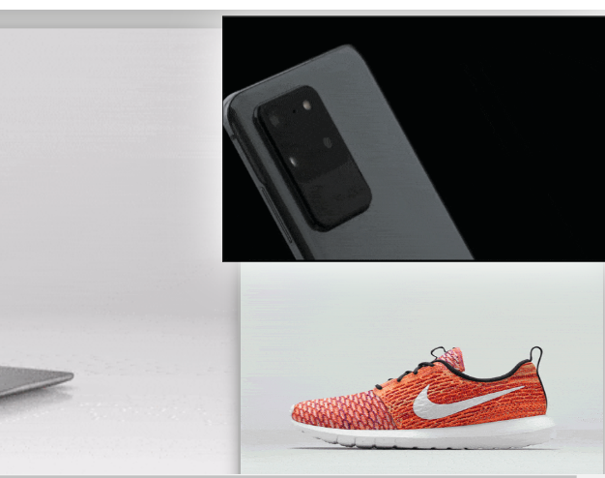

!! Most of the Banners are self Created (one sample)



USE OF JAVA SCRIPT

We have tried to use Java script in two places one of which is given below:

(in login page)

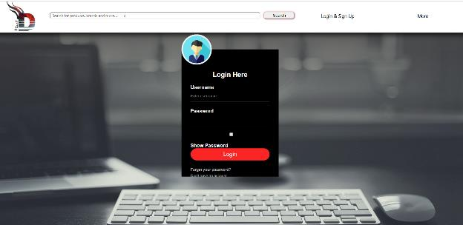

in showing password java script is being used

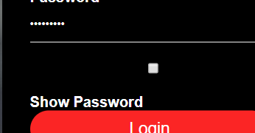(HIDDEN)

(Password shown)

JAVA SCRIPT

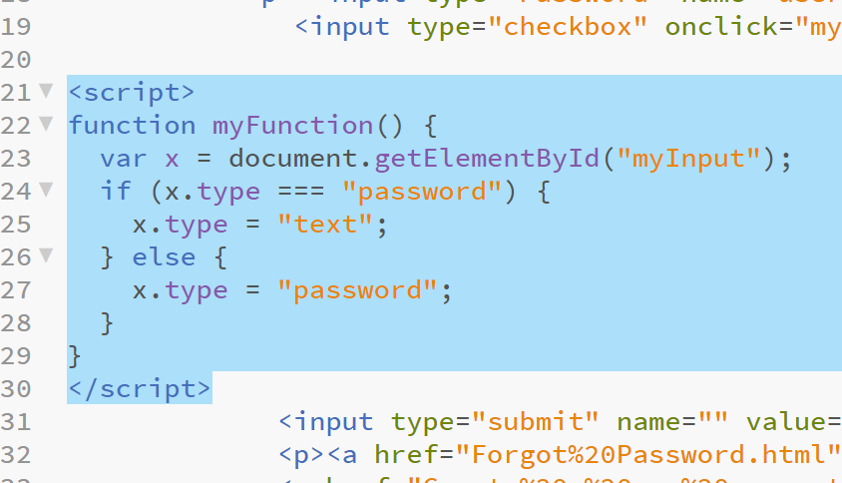

** Important info. :

Search Box don’t work.

We have not created NEED HELP page it could have further increased file size;

Website Works well on Google Chrome

References

Depending on Page to Page we refer to many websites and YouTube videos

GIVEN BELOW ::

* W3 Schools (Mostly Used)
* Apple/Rolex Brand Main Website
* YouTube :
  + For Dropdown: <https://youtu.be/ahTNJS3zcR4>
  + For Footer : <https://youtu.be/N6sgHA6YxVM>

For Compressing Pictures Following site is used ::

<https://compressjpeg.com/>

